|  | INTERNATIONAL TELECOMMUNICATION UNION  **TELECOMMUNICATION** **STANDARDIZATION SECTOR**  STUDY PERIOD 2022-2024 | | **Focus Group on AI Native Networks** | |
| --- | --- | --- | --- | --- |
| **AINN-I-xx** | |
| **Original: English** | |
| **Question(s):** | | N/A | Virtual, TBD 2024 | |
| **INPUT DOCUMENT** | | | | |
| **Source:** | | *Tenali* | | |
| **Title:** | | *Tenali Team - Report on* *ITU WTSA Hackathon 2024 – A midnight Robbery* | | |
| **Contact:** | | Raman | | E-mail: name@gmail.com |

| **Abstract:** | This document contains the submission of a report for Tenali Team towards ITU WTSA Hackathon 2024 for use case *A midnight Robbery.* |
| --- | --- |

## Use case introduction: **“A midnight Robbery”**

A midnight, when everyone is in deep sleep. **The thief moved silently**, thinking he was unnoticed. But as soon as he stepped inside, a motion-detection camera hidden in the corner sprang to life.

The camera, equipped with advanced video surveillance and QoS optimization, immediately began tracking the thief's every move. High-priority resources were allocated to ensure the camera's feed remained crystal clear, even in the low light. Within seconds, **an alert was sent to the nearest police station, along with live footage of the intruder**.

The thief is still unaware that he is getting caught by camera and alerts been received to police.

Consider the scene map below:

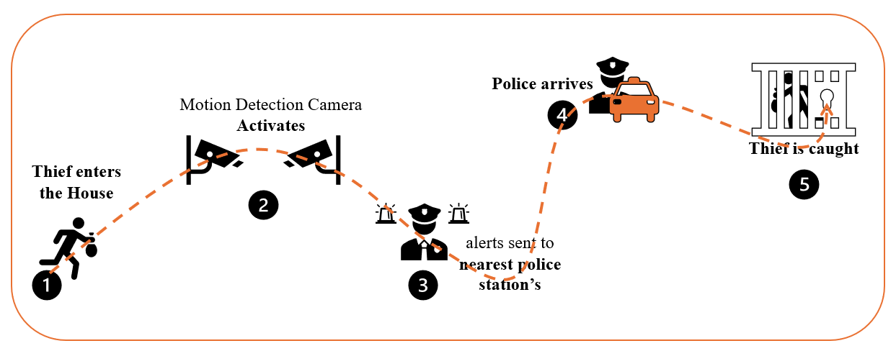

Phase 1: Thief Enters the House

Phase 2: Motion Detection Camera Activates

Phase 3: Alert Sent to Nearest Police Station

Phase 4: Continuous Monitoring happens and live tracking details send to police

Phase 5: Police arrives

Phase 6: Thief is Caught by Police

Note: If the police not responded on time, then it will capture and give the live tracking of the thief by activating nearby cameras and base stations.

Clause-2: use case requirements

Clause-3: PS1: pipeline design

* AI /ML Concept used is event analysis and anomaly detection

Clause-4: PS2: xApp design

* Open RAN concept used is QoS optimization for video surveillance services

Clause-5: Relation to Standards.

Clause-6: Code submission details

Clause-7: Self-Testing results

_________________